Mount Litera Zee School, Haridwar
Syllabus Term-II (2016-17)
Class-VIII
SA 2
Subject | Syllabus
ENGLISH | Gulmohar- L-9: A night to forget, L-11: Bodyline, L-12: The Merchant of Venice  Poem- Where the mind is without fear, A Poison tree, All the world's a stage.  Grammar- L- 13, 17, 18, 19, 20, 21, 22, 24 and 25.  Writing- Story writing, Report writing, Formal letter writing.
HINDI | 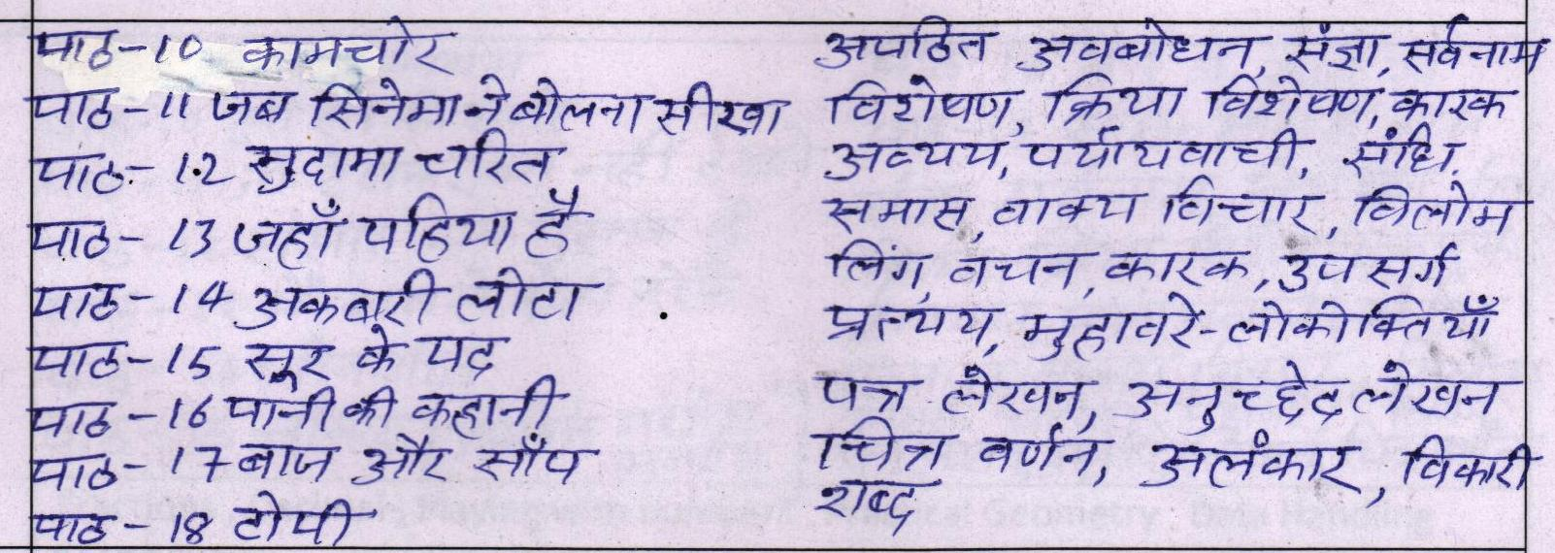
Maths | Cubes and Cube roots , Practical Geometry, Visualising Solid Shapes , Linear Equations in One Variable , Data Handling , Introduction to Graphs , Mensuration.
SCIENCE | L-6 Conservation of Plants and Animals , L-8 Age of Adolescence, L-9 Reproduction ,L-12 Sound ,L-13 Chemical Effects of current , L-14 Some natural phenomena ,L-17 Human Intervention in Natural Phenomena ,L-18 Pollution of Air and Water
S.ST | Ch - 9 Challanges of the caste system, ch 11 Flowering of arts and literature,ch -12 March to freedom,ch- 13 Path beyond freedom, ch 20 Industries - their classifications, ch - 21 Major industries, ch 23 - Human resources, ch -24 Disaster management , ch - 25 Earthquakes, ch - 26 Weather -related disasters, ch - 27 Man made disasters. ch -33 The police and the courts, ch - 34 The states and the social justice, ch - 35 Untouchability, ch - 36 The government and economic development.
SANSKRIT | 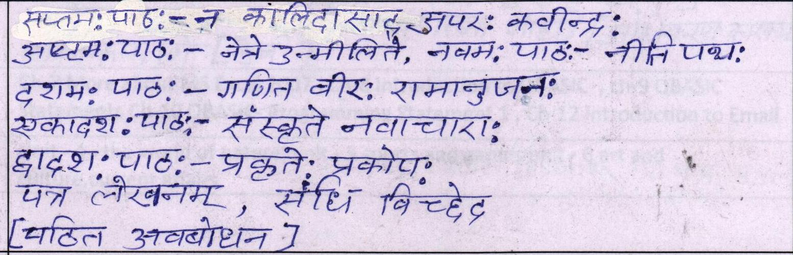
COMPUTERS | Ch-6 Sequential Programming in VB , Ch-7 Conditional Programming in VB , Ch- 8 Repetition Programming in VB , Ch-9 Creating Menu in MDI Application , Ch-11 Elementary C++ , Ch-14 Troubleshooting
G.K | Unit - 4 - The world of nature, unit - 5 Sports and games unit - 6 Art and culture, Current affairs.

